The Python code provided in this article is mainly divided into three files, ‘MatrixDft.py’, ‘Light.py’ and ‘Time_test.py’. The file ‘Light.py’ contains two classes: Gauss_beam and LightPropagate. Readers can know the function of each module according to the name of the file and class.

The calculation time of different propagation methods in Python and MATLAB is compared as follows.

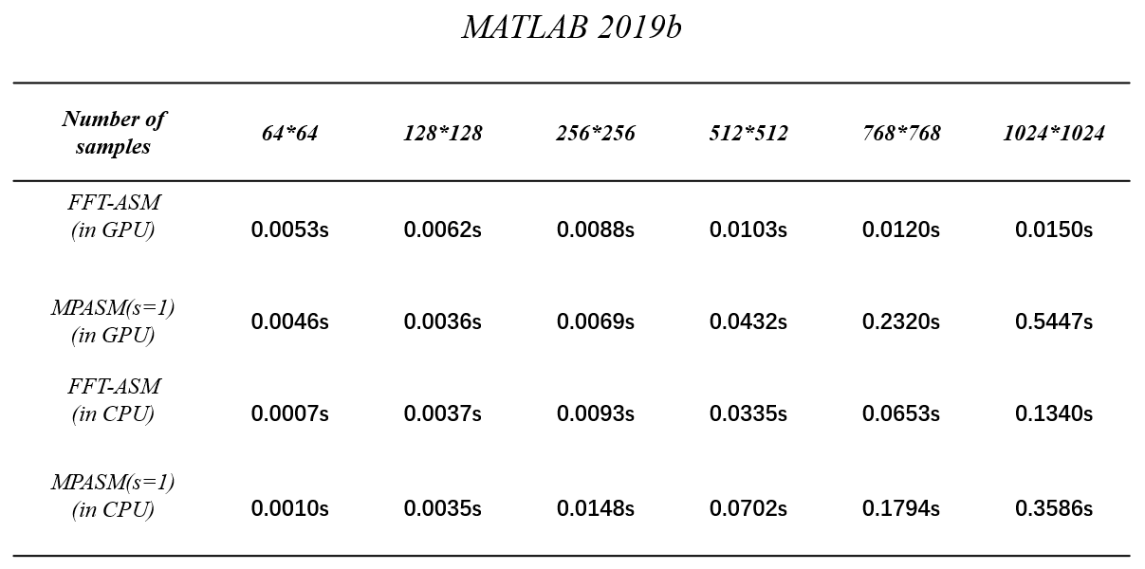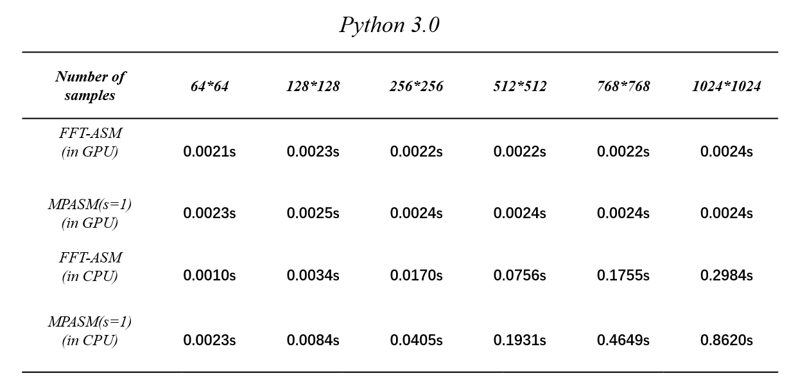
It can be seen from the above tables that the speed of matrix operations in Python is much slower than that of MATLAB in CPU. There is another important piece of information in the above table. The computing speed of GPU is much faster than that of CPU. However, I doubt the accuracy of the Python timing function, so this data is not included in the manuscript.

